Automated Peripheral Blood Smear Screening Using YOLOv10 for Blood Cell Identification and Counting

The accuracy of manually counting each type of cell in a peripheral blood smear, i.e., red blood cells (RBCs), white blood cells (WBCs), and platelets in a complete blood count report depends heavily upon an individual's ability to use a microscope accurately; however, this is time consuming and very prone to observer error (both inter-observer and intra-observer), and expensive automated hematology analyzers that are designed to perform these same tasks have their own drawbacks such as failure when presented with artifact or unusual morphology. In this paper, we present a blood cell detection and counting pipeline based on YOLO v10 for the purpose of identifying RBCs, WBCs, and platelets from microscopic smear images. The training data set consists of smear images that have been annotated with YOLO bounding boxes for the three different cell types. Prior to running YOLO v10 on the images, a series of image processing operations were performed to normalize and resize the images to a uniform size, convert them to grayscale, apply a Gaussian blur to smooth out the images, and then apply an adaptive threshold to enhance the cell boundary information while suppressing noise. We also used a rule-based refinement process to help resolve label inconsistencies due to the fact that some cell types appear similar in terms of size and/or color. We applied selective image augmentation techniques to our smaller class populations because they represent only 5% of the total population (i.e., 100 images) and therefore require additional examples to provide sufficient diversity. We employed multiple scales of feature extraction and fusion through the use of both a Feature Pyramid Network (FPN) and Path Aggregation Network (PANet) with Cross Stage Partial ELAN (CSP-ELAN) blocks as part of the backbone, followed by separate classification and box regression networks with decoupled heads, and finally non-maximum suppression to refine the output of the network. Our qualitative results demonstrate the ability of our system to detect all types of cells reliably even when they are located in a crowded or overlapping area, identify white blood cells based on morphology and staining patterns, and localize small platelet structures even when the illumination is varied. Ultimately, our long term goal is to evaluate our system on a larger and more diverse clinical dataset that includes abnormal cells, and to validate our system in a laboratory setting.

Keywords:

INTRODUCTION:
Blood cell counting is essential for diagnosis and monitoring of a range of clinical conditions, the complete blood count (CBC) is one of the most common laboratory tests ordered. It provides counts and indices of red blood cells (RBCs), white blood cells (WBCs) and platelets, which aid in the identification and monitoring of conditions such as anaemia, infection, haematological malignancy and treatment toxicities. Blood cell counting is estimated to be one of the most frequently requested laboratory tests, with an estimated 1.5 billion CBC tests performed annually worldwide, and approximately 500 million annual CBC tests conducted in the United States, indicating its central role in routine healthcare. Reliable blood cell counting is further required due to the significant global burden of blood-related diseases. Globally, anaemia affects approximately one in four individuals, with approximately 1.9–2.0 billion individuals being affected by anaemia of all ages. WHO estimates indicate that approximately 40% of children aged 6–59 months, 37% of pregnant women, and 30% of women aged 15–49 years are anaemic, with the greatest burden of anaemia found in low- and middle-income countries.

Automated blood cell counting is commonly performed using automated haematology analysers, followed by manual microscopic examination of stained peripheral blood smears in samples identified as abnormal by the automated analyser. Automated analysers provide high-throughput however, they are costly, require frequent calibration and maintenance and may fail to identify atypical cell morphologies or severely abnormal samples. Expert haematologists continue to perform manual smear examination, which is considered the gold standard for morphologic abnormalities, however, manual smear examination is a time-consuming and labour-intensive process, and is also subject to considerable inter- and intra-observer variability, particularly in high volume laboratories and resource-poor locations where skilled personnel are in short supply. This creates an urgent requirement for robust, low-cost, and scalable, automated approaches to the detection and counting of blood cells from digital images.

Recent developments in computer vision and deep learning have provided an opportunity to develop solutions to this challenge. Convolutional Neural Networks (CNNs), fully convolutional segmentation models (such as U-Net) were implemented for simultaneous detection and counting of red blood cells (RBCs), white blood cells (WBCs), and platelets in microscopic smear images, with good accuracy and rapid processing speeds, which are ideal for use within clinical workflows.

Although there are many advancements in the field of detecting and counting blood cells, there are a number of challenges remaining. Most of the current models have been trained using relatively small or limited, homogeneous datasets, which limits their ability to generalize across variations in staining protocols, microscope types, illumination conditions, and patient populations. Other factors which impact model performance include overlapping cells, artifacts, poor contrast, and rare cell types. The purpose of this study was to address the problem of automatically detecting and counting blood cells in microscopic peripheral smear images using deep learning. For a color blood smear image, the goal was to accurately detect individual red blood cells (RBCs), white blood cells (WBCs), and platelets (including overlapping and occluded cells); Ultimately, the goal was to decrease the amount of manual labor required for blood cell counting, minimize observer variability, and make blood cell analysis possible on a larger scale in both resource-rich and resource-poor clinical environments.

LITERATURE SURVEY:

A number of recent studies have utilized deep learning and clinical data analytics for medical image-based detection and medical diagnosis. A study by Maram et al.[1], addressed the issue of secure medical image transmission by implementing a color secret sharing protocol for medical image privacy protection in health care systems. Sabeena et al.,[2] found that Red Cell Distribution Width (RDW), is a strong biomarker for diagnosing conditions associated with inflammation and anemia, making it a cost-effective method of monitoring diseases. M. K. Mayee et al,[3] used deep learning architectures such as ResNet50 and InceptionV3 with GAN-based augmentation to improve the accuracy of medical diagnostics in medical images. Ramana et al., [4] created a lightweight deep CNN using the Ricker Wavelet Transform, to increase the accuracy of early-stage cancer detection at lower computational complexity levels than previously known methods. A further study was conducted by Emine Cengil et al., [5] who established a hybrid framework that utilizes ResNet18–SVM for white blood cell classification, with a classification accuracy of 99.83% demonstrating the ability to combine traditional machine learning classifiers with deep feature extraction for disease analysis.

Recent research has also shown the effectiveness of YOLO-based object detection models for automated blood cell analysis utilizing deep learning techniques. The use of a ResNet B3 based model proposed by Aditya Kumar [6], was able to learn discriminative features from microscopic images and achieve 99.63% accuracy in blood cell classification. Pooja Mehta [7] researched YOLO-based detection models and demonstrated that YOLOv5 provides accurate and fast blood cell detection capabilities that can be used to improve the efficiency of clinical workflows. Francesca Isabella [8] tested YOLOv5 for white blood cell detection and counting in porcine blood smear images, obtaining high localization performance with a mean average precision of 99%. Kaung Myat Naing et al. [9] tested different versions of YOLO including YOLOv3 for the detection of acute myeloid leukemia cells and achieved over 92% precision and sensitivity. Additionally, Shilpa Chowdary [10] compared various detection frameworks and determined that YOLOv10 provides superior real time accuracy, and that lightweight models provide better performance in low resource environments.

The most recent research has been focused on increasing the capability of YOLO architectures through the integration of transformer-based models to improve the accuracy of blood cell detection. Servas Adolph Tarimo [11] proposed a hybrid YOLO–Vision Transformer framework that was able to capture both local and global features of images and achieve a classification accuracy of 96.449%. Yi He [12] proposed a new version of the YOLOv5s-TRBC model that improved feature representations and obtained a mean average precision of 93.5%. Zhenquan Xu et al. [13] modified the YOLOv9 model by adding the AKELAN4 module, providing significant improvements in performance and efficiency over previous models. Yonglin Wu et al. [14] proposed the SW-YOLO model, which provided superior performance to all other algorithms and produced mAP values greater than 93%, demonstrating significant practical potential for use in applications. Finally, Ming Kang et al. [15] proposed the CST-YOLO model that uses YOLOv7 along with a CNN-Swin Transformer, providing superior detection precision and robustness for automated blood cell analysis.

Methodology:
3.1 Dataset:
This research utilized a dataset consisting of images of microscopic blood smears that include all three cell types — Red Blood Cells (RBCs), White Blood Cells (WBCs) and Platelets. The entire dataset is annotated using bounding boxes in the YOLO format. To be used to train the YOLO model, the dataset had to undergo a series of preprocessing steps including normalization of the images, removal of any labels which did not contain an image or contained incorrect data, and correction of the dimension of the bounding boxes to match the correct cell type. In addition, a rule-based process was implemented to refine the annotation process by ensuring the classification between RBCs and other cells would be based upon both the size and color characteristics of the cells. An examination of the class distribution showed that the dataset is naturally imbalanced with RBCs representing approximately 90% of the cells in the dataset. Therefore, augmentation methods were selectively used on the minority classes WBCs and Platelets. Examination of images from the dataset displaying the images with the bounding boxes and statistical displays of the data confirmed the accuracy and consistency of the labeling allowing the dataset to provide a stable base for training the YOLO model.

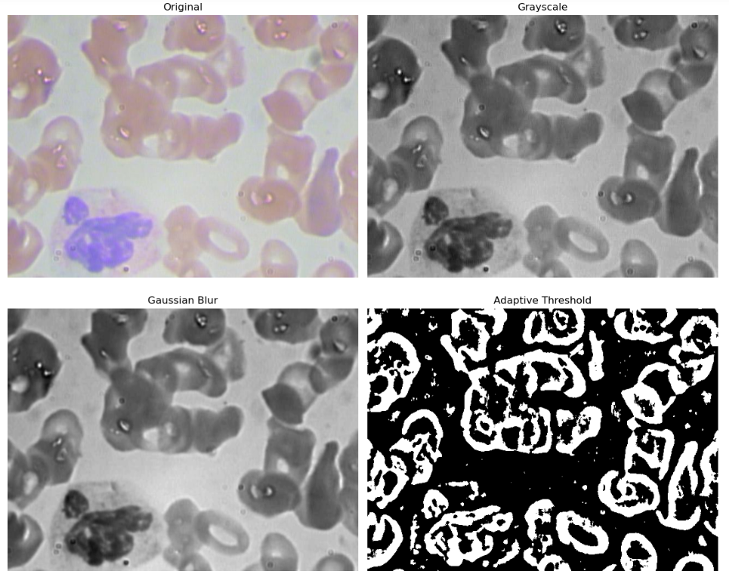

Figure 1:Preprocessing stages applied to microscopic blood smear images.
3.2 Data Preprocessing:
The pre-processing pipeline illustrated in Figure 1 demonstrates four sequential operations applied to the microscopic blood smear images to enhance cell visibility and improve segmentation accuracy. The Original image represents the raw RGB microscopy capture, showing varying illumination, staining artifacts, and overlapping cells. The image is first converted to Grayscale, reducing computational complexity while preserving essential structural details of RBCs, WBCs, and platelets. This is followed by Gaussian Blurring, which smooths the image and suppresses high-frequency noise such as grain artifacts and camera sensor fluctuations. Finally, Adaptive Thresholding is applied to generate a binary mask that highlights prominent cell boundaries. This step enhances contrast between cellular components and the background, enabling more effective contour detection and bounding-box generation during the annotation and training phases. Overall, the preprocessing steps significantly improve the clarity of morphological features, making the dataset more suitable for robust blood-cell detection using YOLO-based deep learning models.

3.3 DEPLOYMENT

YOLOv10 was used as the primary deep learning structure in this research for the identification and localization of Red Blood Cells (RBCs), White Blood Cells (WBCs), and Platelets from blood smear microscopic images. YOLOv10 is a next-generation, one-stage object detector that has faster inference speeds than previous versions of YOLOv10 and has better feature extraction capabilities; therefore, it is suitable for use in real-time biomedical image analysis. The YOLOv10 model utilizes a lightweight, yet hierarchically rich backbone to obtain multi-scale spatial features, followed by a feature pyramid and cross-scale aggregation to preserve the fine-grained morphological characteristics necessary for blood cell recognition. In addition, the prediction head conducts bounding-box regression, objectness estimation, and multi-class classification in a single step, which reduces computational requirements while improving the accuracy of the results.

In order to adapt YOLOv10 to the hematology field, the dataset was annotated with three target classes (RBCs, WBCs, and Platelets), and training was conducted using optimal hyperparameters and data augmentation techniques that promote robustness to variations in staining and lighting. Improved spatial resolution in the feature maps and improved detection mechanisms for small objects (e.g., platelets) were also achieved using refined anchor-free detection methods. Therefore, the YOLOv10 architecture represents a fast and accurate method for performing automated blood cell analysis, and demonstrates its potential to be successfully used in a variety of microscopic conditions.

DEPLOYMENT MODEL
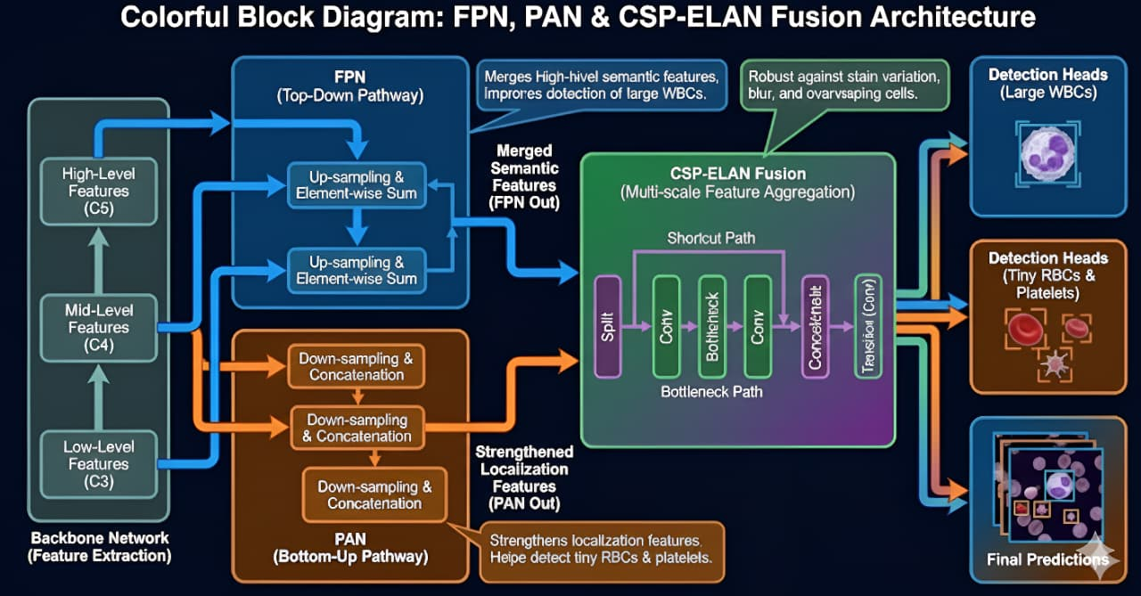

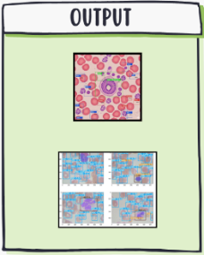
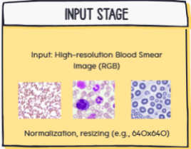

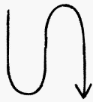
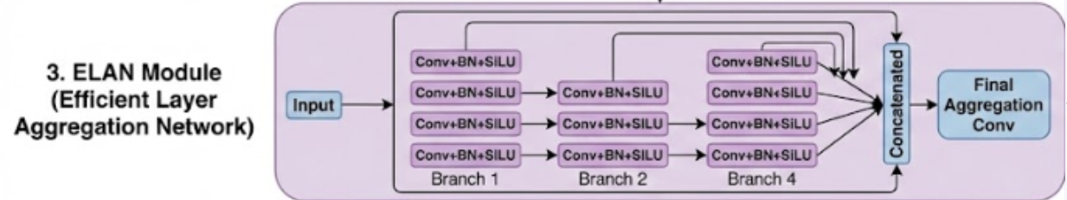
Figure 2: Proposed FPN–PAN–CSP-ELAN Fusion Architecture for Blood Cell Detection

As illustrated in the figure 2, the proposed architecture uses the YOLOv10 architecture to automatically identify and classify red blood cells (RBCs), white blood cells (WBCs), and platelets in microscopic blood smear images. As depicted in the diagram illustrating the architecture, the pipeline includes an input pre-processing phase, followed by backbone feature extraction, multi-scale feature integration using FPN and PAN, CSP-ELAN integration, and finally, detection heads.

Firstly, the RGB images of blood smears are normalized and downsized to the size of the network input. The images are then sent to the backbone network, which extracts hierarchical feature maps at different levels of detail. Features captured in lower layers capture detailed textures and edges, whereas higher level layers capture the high-level semantic representations related to the morphology of blood cells, including the circular form of RBCs, lobated form of WBC nuclei, and the small platelet structures.

The feature maps produced by the backbone network are routed to the neck, where they are integrated using both a Feature Pyramid Network (FPN) and a Path Aggregation Network (PAN). The FPN facilitates top-down fusion of features, allowing high-level semantic information to be combined with low-level spatial details in order to provide better detection of larger cells, such as WBCs. On the other hand, the PAN promotes the downward flow of information, thereby enhancing localization features required for detecting smaller, denser cells, such as RBCs and platelets.

To further improve the representation across different scales, CSP-ELAN fusion is applied to allow for efficient combination of features across different resolutions, while ensuring that the computation is kept reasonable. This fusion provides additional robustness to the variations of stain, blur, and overlap among cells, which can occur frequently in blood smear images.

Finally, the fused features are directed towards the decoupled detection heads, which execute the independent classification and bounding box regression. The detection heads produce the classification of the cell (RBC, WBC, or platelet), the confidence score of the classification, and the exact location of the classified cell. Afterward, non-maximum suppression is performed on the outputs of the detection heads in order to remove the redundant classifications and to produce the accurate localizations, classifications, and counts of the cells.

4. RESULTS:

The overall performance of the proposed YOLOv10-based blood cell detection system was examined with the use of microscopic blood smear images. From an evaluation standpoint, the quality of the detection performed by this system indicates that the system is capable of accurately detecting and identifying both red blood cells (RBCs) and white blood cells (WBCs) as well as platelets in poor imaging environments. Even though the system was tested on many densely populated and partially overlapping regions typical of peripheral blood smear images; the system demonstrated to perform reasonably well in those areas.

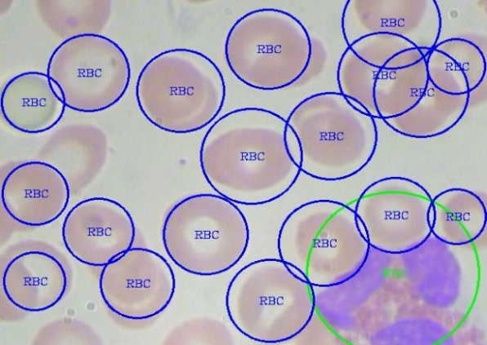
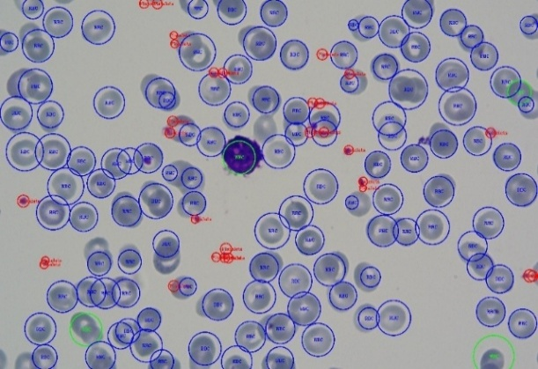

Fig 3&4: YOLOv10-based blood cell detection in a microscopic blood smear image
Both Figs. 3 and 4 demonstrate that the model has been successful in detecting virtually all RBCs, WBCs and platelets that could be seen within each image, regardless of the variation in the size, shape or staining intensity of the cells. The predicted bounding box of the cells appears to have very little discrepancy from the actual boundaries of the cells; therefore, the backbone module and multi-scale feature fusion module appear to be performing appropriately in extracting morphological characteristics of the cells at varying scales.

Additionally, the model demonstrates the ability to identify WBCs through their larger dimensions, darkly stained nucleus and strong staining in comparison to surrounding RBCs, even when the WBCs were positioned near other RBCs that overlapped with each other. Smaller platelet structures were also identified with great accuracy, demonstrating the model's capability to detect objects of smaller dimension.

Overall, the proposed system performed reliably in crowded and low contrast regions; and did not merge individual cells into one object in the detection process. Furthermore, there were no significant numbers of false positives detected, which demonstrates the model had good specificity. In addition, the model demonstrated a high degree of visibility in detecting cells that were observable in the images, which indicates the model had good sensitivity. Overall, the above-mentioned results indicate that the proposed YOLOv10-based model has been successful in localizing and classifying RBCs, WBCs and platelets, thereby providing a reliable method for automated blood cell detection and counting.

CONCLUSION:
This work demonstrated an automatic blood cell detection and count platform using YOLOv10 to detect RBCs, WBCs and platelets from peripheral blood smear images at the microscopic level. The preprocessing pipeline, including normalization/resizing, grayscale conversion, Gaussian blur and adaptive thresholding, was used to enhance the clarity of cell boundaries and remove/lessen the effects of background noise in smears which would enhance the overall robustness of the detector under common smear artifacts and/or illumination changes. Additionally, a rule-based post-processing step was developed to further refine the labeling process where label inconsistency arose due to similarity in size or color among the different cell types, and selective data augmentation techniques were also implemented to help mitigate the inherent class imbalances found in the dataset.

The qualitative results of the proposed feature fusion method and decoupling of the detection heads provided reliable localizations and classifications in areas of high cell density and partial overlap of the objects being detected; consistent identification of WBCs based on staining characteristics and morphology, and accurate detection/localization of small platelet structures. While this study has shown good feasibility for rapid, semi-autonomous analysis of smears, it is limited in its performance by both the number of samples and diversity in the dataset, and is primarily evaluated against normal cell categories. Future studies will be focused on increasing the scope and depth of training and validation across larger multi-center datasets, including abnormal and disease specific cell morphologies, providing detailed quantitative metrics and evaluating the utility of the pipeline in actual clinical laboratory settings. Once expanded in these manners, the proposed system will have potential use as a practical decision support system to decrease the manual burden and observer variability associated with routine hematologic testing.

REFERENCE:

- B. Maram, M. S. S. Sai, M. Vanniappan, T. A. S. Srinivas, P. Nagaraju and U. D. Prasan, "Protecting Medical Image Transmission: Color Secret Sharing Protocol for Enhanced Security," 2024 International Conference on Artificial Intelligence and Quantum Computation-Based Sensor Application (ICAIQSA), Nagpur, India, 2024, pp. 1-6, doi: 10.1109/ICAIQSA64000.2024.10882318
- Sabeena, dr s., Dr. Venkatraghavan atm, and Dr. Anusuya. “red cell distribution width as a marker of disease activity and anemia in inflammatory bowel disease: a retrospective analysis.”
- M. K. Mayee and M. H. Khanam, "Utilizing Advanced Deep Learning for Accurate Multilabel Classification of Ocular Diseases," 2024 1st International Conference on Cognitive, Green and Ubiquitous Computing (IC-CGU), Bhubaneswar, India, 2024, pp. 1-6, doi: 10.1109/IC-CGU58078.2024.10530831.

- K. S. Ramana, Y. I. Priyadarshini, H. J. Jambukesh, R. Singh, M. Kandasamy and B. V. Kumar, "A 5G NB-IoT Infrastructure for Secured Demand-Side Information Transmission and Predictive Analyses in Smarter Grids," 2023 3rd International Conference on Advance Computing and Innovative Technologies in Engineering (ICACITE), Greater Noida, India, 2023, pp. 1917-1922, doi: 10.1109/ICACITE57410.2023.10182463.

- Cengil, E., Cinar, A., & Yıldırım, M. (2021). A hybrid approach for efficient multi‐classification of white blood cells based on transfer learning techniques and traditional machine learning methods. Concurrency and Computation: Practice and Experience, 34. https://doi.org/10.1002/cpe.6756.

- Kumar, A., & Nelson, L. (2025). Deep Learning-based Blood Cell Classification using EfficientNetB3 Architecture. 2025 6th International Conference on Mobile Computing and Sustainable Informatics (ICMCSI), 954-960. https://doi.org/10.1109/icmcsi64620.2025.10883188.

- Mehta, P., Vaghela, R., Pansuriya, N., Sarda, J., Bhatt, N., Bhoi, A., & Srinivasu, P. (2025). Benchmarking YOLO Variants for Enhanced Blood Cell Detection. International Journal of Imaging Systems and Technology, 35.

- Choudhary, S., Kumar, S., Siddhaarth, P., Charitasri, G., Gulhane, M., Rakesh, N., Mon, F., Al-Rasheed, A., Getahun, M., & Soufiene, B. (2025). Advancing blood cell detection and classification: performance evaluation of modern deep learning models. BMC Medical Informatics and Decision Making, 25.

- Tarimo, S., Jang, M., Ngasa, E., Shin, H., Shin, H., & Woo, J. (2023). WBC YOLO-ViT: 2 Way - 2 stage white blood cell detection and classification with a combination of YOLOv5 and vision transformer. Computers in biology and medicine, 169, 107875

- Escobar, F., Alipo-On, J., Novia, J., Tan, M., Karim, H., & Aldahoul, N. (2023). Automated counting of white blood cells in thin blood smear images. Comput. Electr. Eng., 108, 108710. https://doi.org/10.1016/j.compeleceng.2023.108710.

- Naing, K., Kittichai, V., Tongloy, T., Chuwongin, S., & Boonsang, S. (2021). The Evaluation of Acute Myeloid Leukaemia (AML) Blood Cell Detection Models Using Different YOLO Approaches. bioRxiv.

- He, Y. (2024). Automatic Blood Cell Detection Based on Advanced YOLOv5s Network. IEEE Access, 12, 17639-17650. https://doi.org/10.1109/access.2024.3360142.

- Xu, Z., Zou, J., Long, D., Wei, X., & Yang, G. (2024). Blood Cell Detection: Enhanced YOLOv9 Algorithm. 2024 China Automation Congress (CAC), 4415-4420.

- Wu, Y., Fang, Y., Gao, D., Gao, H., & Ju, Z. (2023). SW-YOLO: Improved YOLOv5s Algorithm for Blood Cell Detection. , 161-172. https://doi.org/10.1007/978-981-99-6489-5_13.

- Kang, M., Ting, C., Ting, F., & Phan, R. (2023). CST-YOLO: A Novel Method for Blood Cell Detection Based on Improved YOLOv7 and CNN-Swin Transformer. ArXiv, abs/2306.14590.

